RESUME
SATISH RAKOTI  Mobile: +91-9703107975  Email: ashok.rakoti@gmail.com | 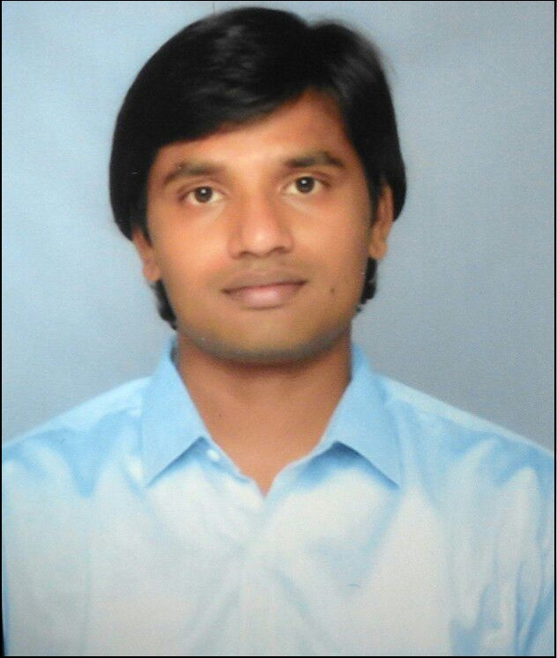

Objective:

To become a successful professional in my field and to work in an innovative and competitive environment.

Experience:

- Working as Senior Survey Programmer in GENPACT India from the last 1 year.
- Worked as Survey Programmer in MRops programming India Pvt. Ltd, Hyderabad for 3 years.

Technical Skills:

- PROGRAMMING:
- C, C++.
- HTML, JavaScript, jQuery-UI, CSS
- ConfirmIT programming, handle sampling and reportal tools.

Experience Chronology:

Survey Programmer ( from 19-06-2012 )
Job profile & Responsibilities :
- Programming and managing online surveys in ConfirmIT.
- Interact with onshore and offshore manager to understand the requirement for an efficient and error free delivery
- Estimate and advice on realistic time lines for survey programming.
- Review survey questionnaires and formulate recommendations to ensure efficient programming and optimal data layout.
- Coordinate with team members for a successful and quality product delivery.
- Complete projects on time and/or notifying appropriate staff with alternate plans when necessary.
- Finding generalized and optimized solutions for complex tasks.
- Working complex setups like Max-diff, DCM, conjoint and typing tool setups.

Web Site Development for KCC ( from 02-04-2012 to 30-04-2012)
JOB PROFILE:
- Developer (freelancer) for the information website for KCC institute and play school.
JOB DESCRIPTION:
- Six page interactive website for children play school.
- Worked with HTML, Classic ASP, Javascript and JQuery.
- Developed, Tested and published the website.

Professional Qualification:

- B.Tech in Computer Science & Engineering with an aggregate of 60.5% from JNTU Kakinada (Dist.), A.P. in 2011.

Achievements:

- Awarded and rewarded with silver award.
Name | : | RAKOTI SATISH
Date Of Birth | : | 07-01-1989
Sex | : | Male
Marital status | : | Single
Nationality | : | Indian
Passport number | : | J1285986
- I got Make A Difference (MAD) award for dedicated and unique way of support.

Personal Details:

Declaration:

I hereby declare that the above-mentioned information is correct up to my knowledge and I bear the responsibility for the correctness of the above-mentioned particulars.

Place:
Date: SATISH RAKOTI

